# MODULE: 2 (HTML)

* Define the terms: Website, Webpage, Web browser, Web server, HTML, CSS

Ans:

1. Website: A collection of web pages and multimedia content accessible through a specific domain name, providing information or services is called Website.

2. Webpage: A single document or file forming part of a website, containing text, images, links, and other media, designed for viewing in web browsers is called Webpage.

3. Web browser: Software application enabling users to access and navigate websites, rendering HTML documents and displaying content in a user-friendly format.

4. Web server: Computer or software that hosts websites, storing website files and delivering them to web browsers upon request .

5. HTML: Hypertext Markup Language, a standardized language used to create the structure and content of webpages, defining elements and their relationships.

6. CSS: Cascading Style Sheets, a style sheet language used to define the presentation and layout of HTML documents, controlling visual aspects such as colors, fonts, and positioning.

* Create a webpage to show “This is my first HTML page”

Ans:

Code:

<!DOCTYPE html>

<html>

<head>

    <title>My First HTML Page</title>

</head>

<body>

    <h1>This is my first HTML page</h1>

</body>

</html>

Output:

* 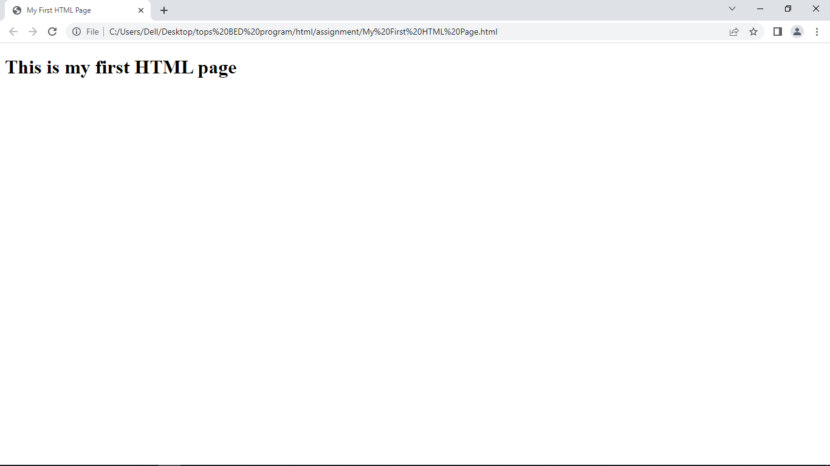Display top 10 IT companies list in html webpage

Ans:

<!DOCTYPE html>

<html>

<head>

    <title>Top 10 IT Companies</title>

</head>

<body>

    <h1>Top 10 IT Companies</h1>

    <ol>

        <li>Microsoft</li>

        <li>Apple</li>

        <li>Amazon</li>

        <li>Google</li>

        <li>IBM</li>

        <li>Intel</li>

        <li>Oracle</li>

        <li>Tesla</li>

        <li>Samsung Electronics</li>

        <li>Tencent</li>

    </ol>

</body>

</html>

Output:

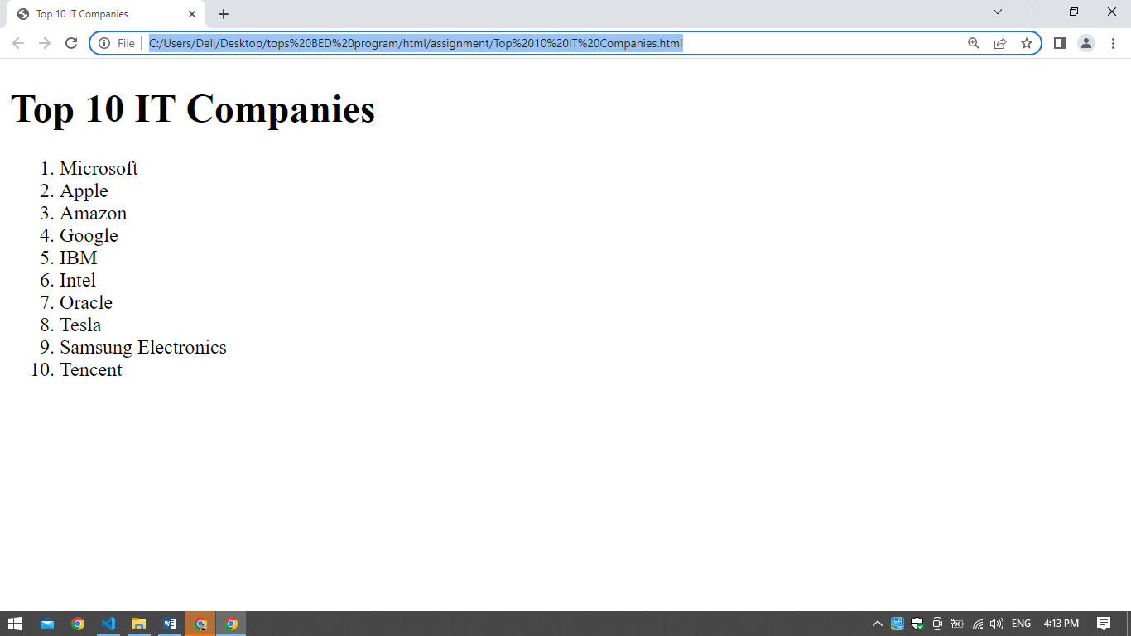

* Create a dropdown list

Ans:

<!DOCTYPE html>

<html>

<head>

    <title>Dropdown List Example</title>

</head>

<body>

    <h1>Select an ITcompany:</h1>

    <select>

        <option value="apple">Apple</option>

        <option value="Amazon">Amazon</option>

        <option value="Google">Google</option>

        <option value="IBM">IBM</option>

    </select>

</body>

</html>

Output:

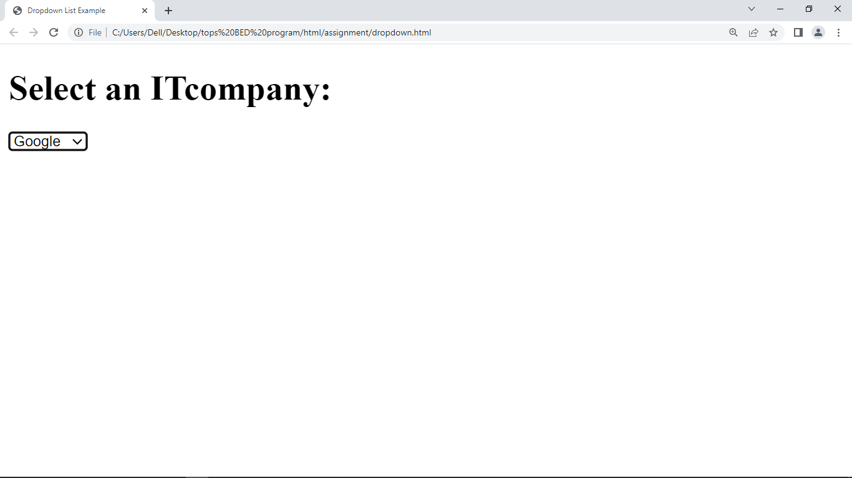

* Create a Table Of college Management system using row span & col span.

Ans:

<!DOCTYPE html>

<html>

<head>

    <title>College Management System</title>

</head>

<body>

    <h1>College Management System</h1>

    <table border="1">

        <tr>

            <th>Year</th>

            <th>Semester</th>

            <th colspan="3">Courses</th>

        </tr>

        <tr>

            <td rowspan="2">1st Year</td>

            <td>1st Semester</td>

            <td colspan="3">Introduction to Programming</td>

        </tr>

        <tr>

            <td>2nd Semester</td>

            <td colspan="3">Database Fundamentals</td>

        </tr>

        <tr>

            <td rowspan="2">2nd Year</td>

            <td>3rd Semester</td>

            <td>Web Development</td>

            <td>Network Security</td>

            <td>Data Structures</td>

        </tr>

        <tr>

            <td>4th Semester</td>

            <td>Software Engineering</td>

            <td>Database Management</td>

            <td>Operating Systems</td>

        </tr>

    </table>

</body>

</html>

Output:

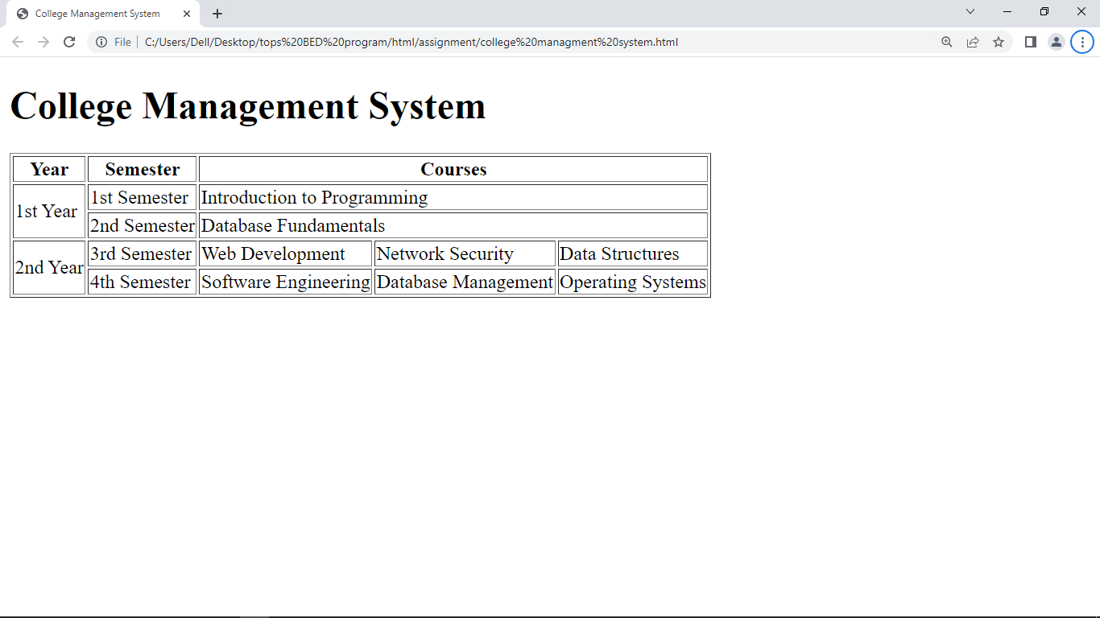

* Create below table using HTML table tags

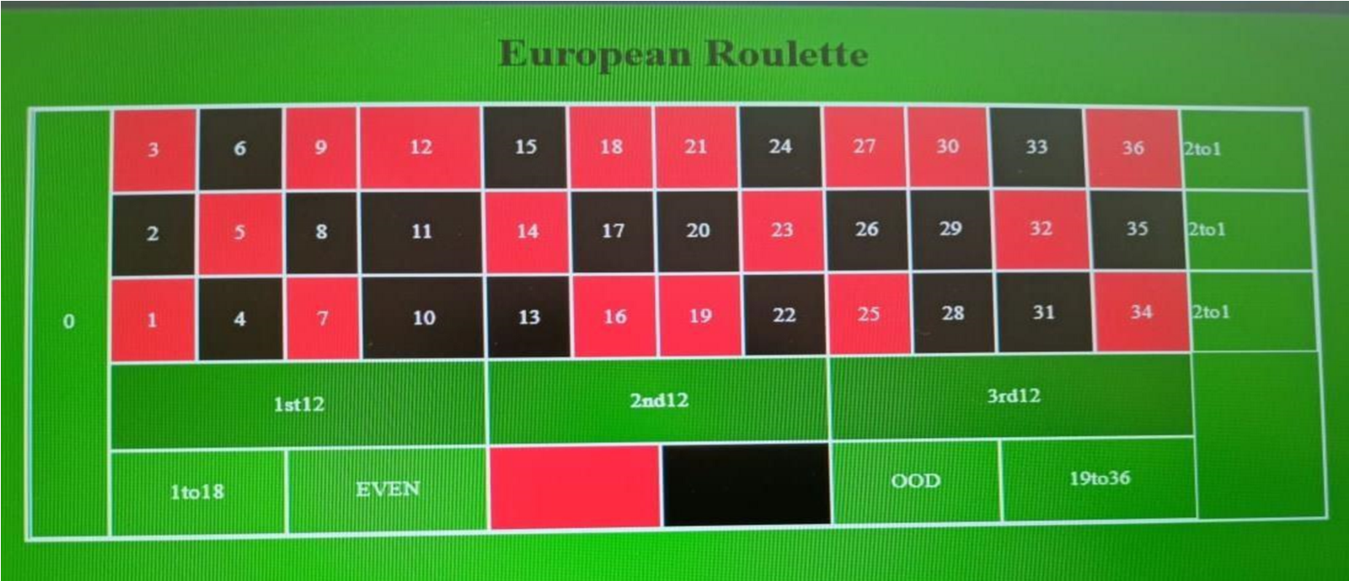

Code:

<!DOCTYPE html>

<html lang="en">

<head>

    <meta charset="UTF-8">

    <meta name="viewport" content="width=device-width, initial-scale=1.0">

    <title>Document</title>

</head>

<body text="white" bgcolor="green" >

    <h1  align="center">European Roulette</h1>

    <div align="center">

    <table  bordercolor="white" border="" cellpadding="10" border="white" border="">

        <tr>

            <td rowspan="5">0</td>

            <td bgcolor="red">3</td>

            <td bgcolor="black">6</td>

            <td bgcolor="red">9</td>

            <td bgcolor="red">12</td>

            <td bgcolor="black" >15</td>

            <td bgcolor="red">18</td>

            <td bgcolor="red">21</td>

            <td bgcolor="black">24</td>

            <td bgcolor="red">27</td>

            <td bgcolor="red">30</td>

            <td bgcolor="black">33</td>

            <td bgcolor="red">36</td>

            <td colspan="2">2to1</td>

        </tr>

        <tr>

            <td bgcolor="black">2</td>

            <td bgcolor="red">5</td>

            <td bgcolor="black">8</td>

            <td bgcolor="black">11</td>

            <td bgcolor="red">14</td>

            <td bgcolor="black">17</td>

            <td bgcolor="black">20</td>

            <td bgcolor="red">23</td>

            <td bgcolor="black">26</td>

            <td bgcolor="black">29</td>

            <td bgcolor="red">32</td>

            <td bgcolor="black">35</td>

            <td colspan="2">2to1</td>

        </tr>

        <tr>

            <td bgcolor="red">1</td>

            <td bgcolor="black">4</td>

            <td bgcolor="red">7</td>

            <td bgcolor="black">10</td>

            <td bgcolor="black">13</td>

            <td bgcolor="red">16</td>

            <td bgcolor="red">19</td>

            <td bgcolor="black">22</td>

            <td bgcolor="red">25</td>

            <td bgcolor="black">28</td>

            <td bgcolor="black">31</td>

            <td bgcolor="red">34</td>

            <td colspan="2">2to1</td>

        </tr>

        <tr>

            <td colspan="4" align="center">1st 12</td>

            <td colspan="4"align="center">2nd 12</td>

            <td colspan="4"align="center">3rd 12</td>

            <td colspan="2" rowspan="2"></td>

        </tr>

        <tr>

            <td colspan="2">1to18</td>

            <td colspan="2">EVEN</td>

            <td colspan="2" bgcolor="red"></td>

            <td colspan="2"bgcolor="black"></td>

            <td colspan="2">odd</td>

            <td colspan="2">19to36</td>

        </tr>

    </table>

</div>

</body>

</html>

Output:

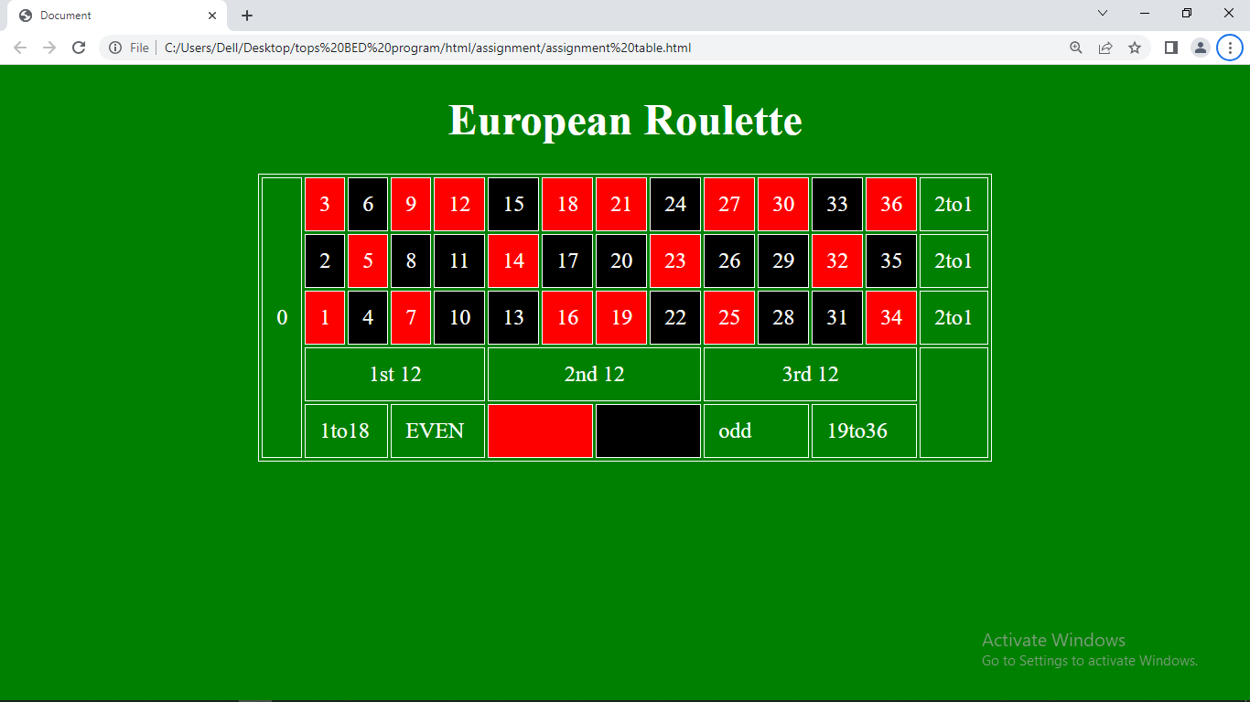

* Create Registration form using HTML, CSS

Code:

Html:

<!DOCTYPE html>

<html>

<head>

  <title>Registration Form</title>

  <link rel="stylesheet" type="text/css" href="C:\Users\Dell\Desktop\tops BED program\html\.vscode\.css">

</head>

<body>

  <div class="container">

    <h2>Registration Form</h2>

    <form>

      <div class="form-group">

        <label for="name">Name:</label>

        <input type="text" id="name" name="name" required>

      </div>

      <div class="form-group">

        <label for="email">Email:</label>

        <input type="email" id="email" name="email" required>

      </div>

      <div class="form-group">

        <label for="password">Password:</label>

        <input type="password" id="password" name="password" required>

      </div>

      <div class="form-group">

        <label for="confirm_password">Confirm Password:</label>

        <input type="password" id="confirm_password" name="confirm_password" required>

      </div>

      <input type="submit" value="Register">

    </form>

  </div>

</body>

</html>

Css:

.container {

    max-width: 400px;

    margin: 0 auto;

    padding: 20px;

    border: 1px solid #ccc;

    border-radius: 5px;

  }

  h2 {

    text-align: center;

  }

  .form-group {

    margin-bottom: 15px;

  }

  label {

    display: block;

    font-weight: bold;

  }

  input[type="text"],

  input[type="email"],

  input[type="password"] {

    width: 100%;

    padding: 10px;

    border: 1px solid #ccc;

    border-radius: 4px;

  }

  input[type="submit"] {

    width: 100%;

    padding: 10px;

    background-color: #4CAF50;

    color: white;

    border: none;

    border-radius: 4px;

    cursor: pointer;

  }

Output:

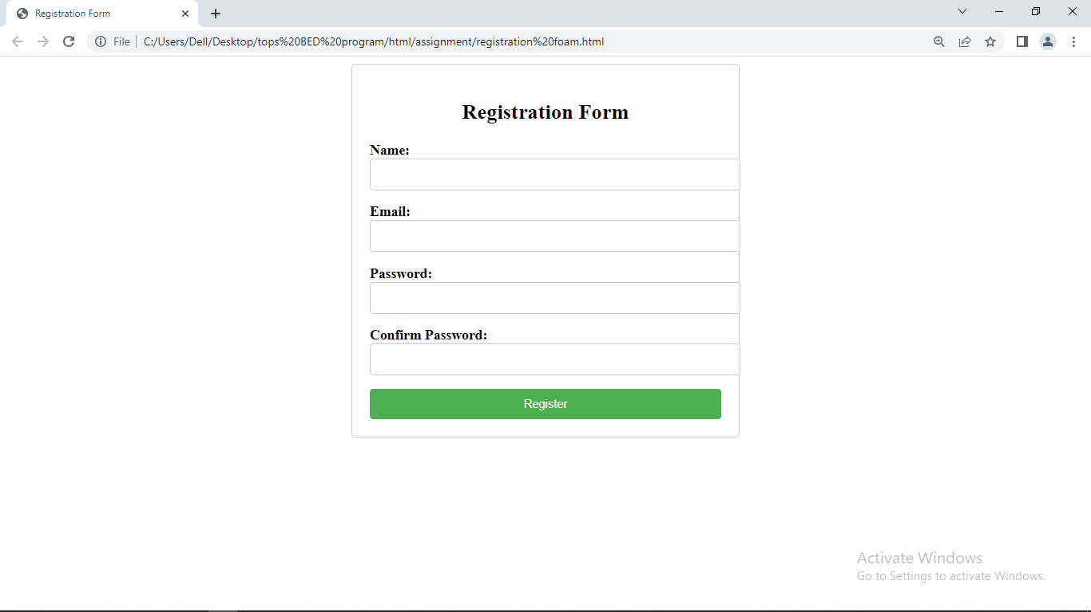

* In how many ways can a CSS be integrated as a web page?

Ans:

Basically there are three ways to integrate CSS in web page:

1. Inline CSS
2. Internal CSS
3. External CSS
4. Inline CSS:

Inline CSS is added directly to html elements using <style> tag.

Eg:

<p style="color: blue;">This is a paragraph with inline CSS.</p>

1. Internal CSS:

Internal CSS is placed within the <style> between the <head> section of HTML Document.

Eg:

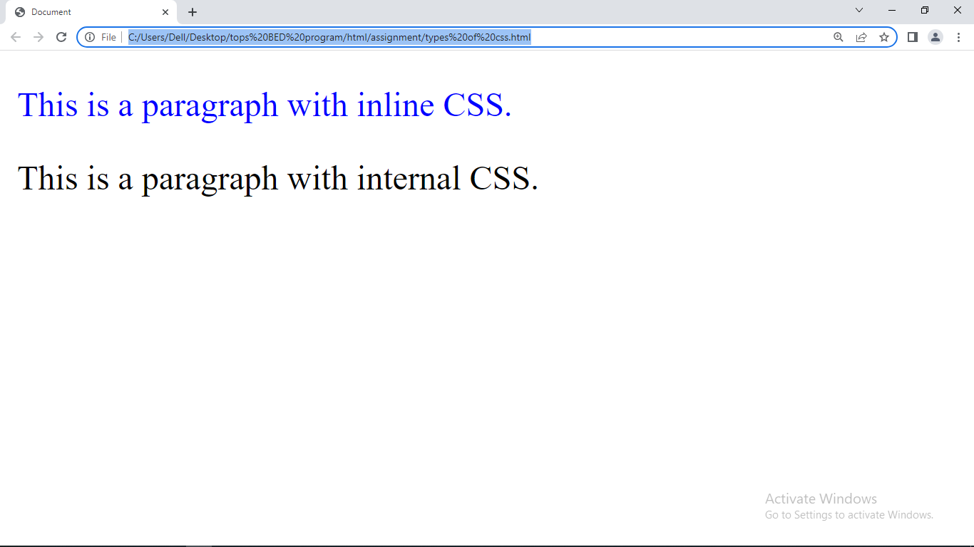

1. External CSS:

External CSS is defined in a seperste CSS file and linked to the HTML document using <link> tag.

Eg:

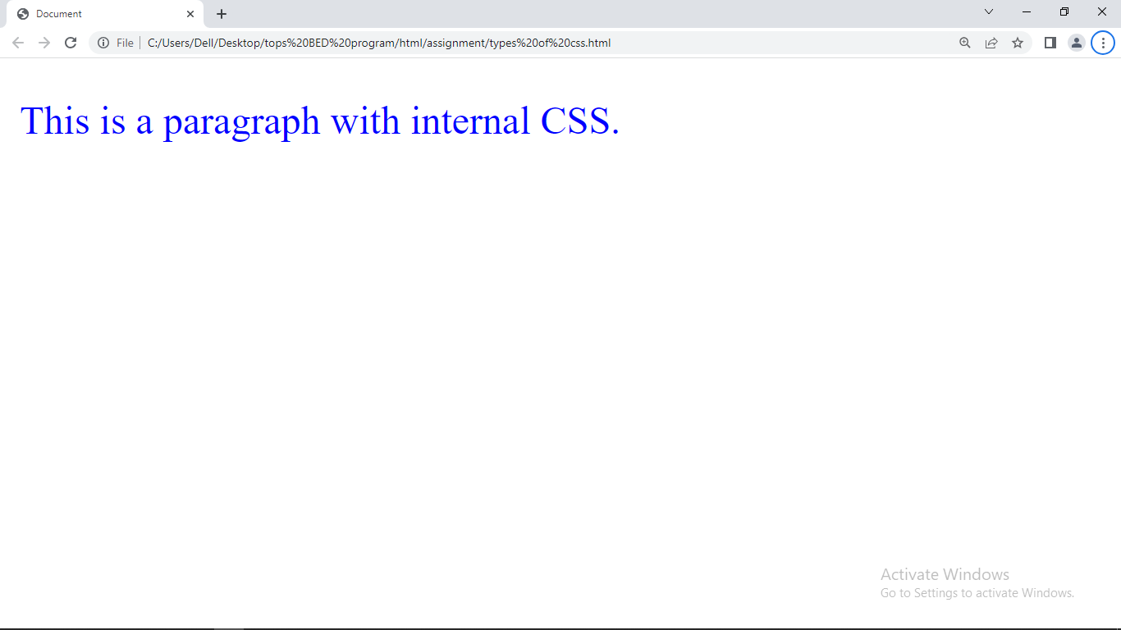

* Create simple three pages using External CSS, Internal CSS, and Inline CSS.

1. Inline CSS:

Inline CSS is added directly to html elements using <style> tag.

Eg:

<p style="color: blue;">This is a paragraph with inline CSS.</p>

1. Internal CSS:

Internal CSS is placed within the <style> between the <head> section of HTML Document.

Eg:



1. External CSS:

External CSS is defined in a seperste CSS file and linked to the HTML document using <link> tag.

Eg:



* Create below page using HTML CSS

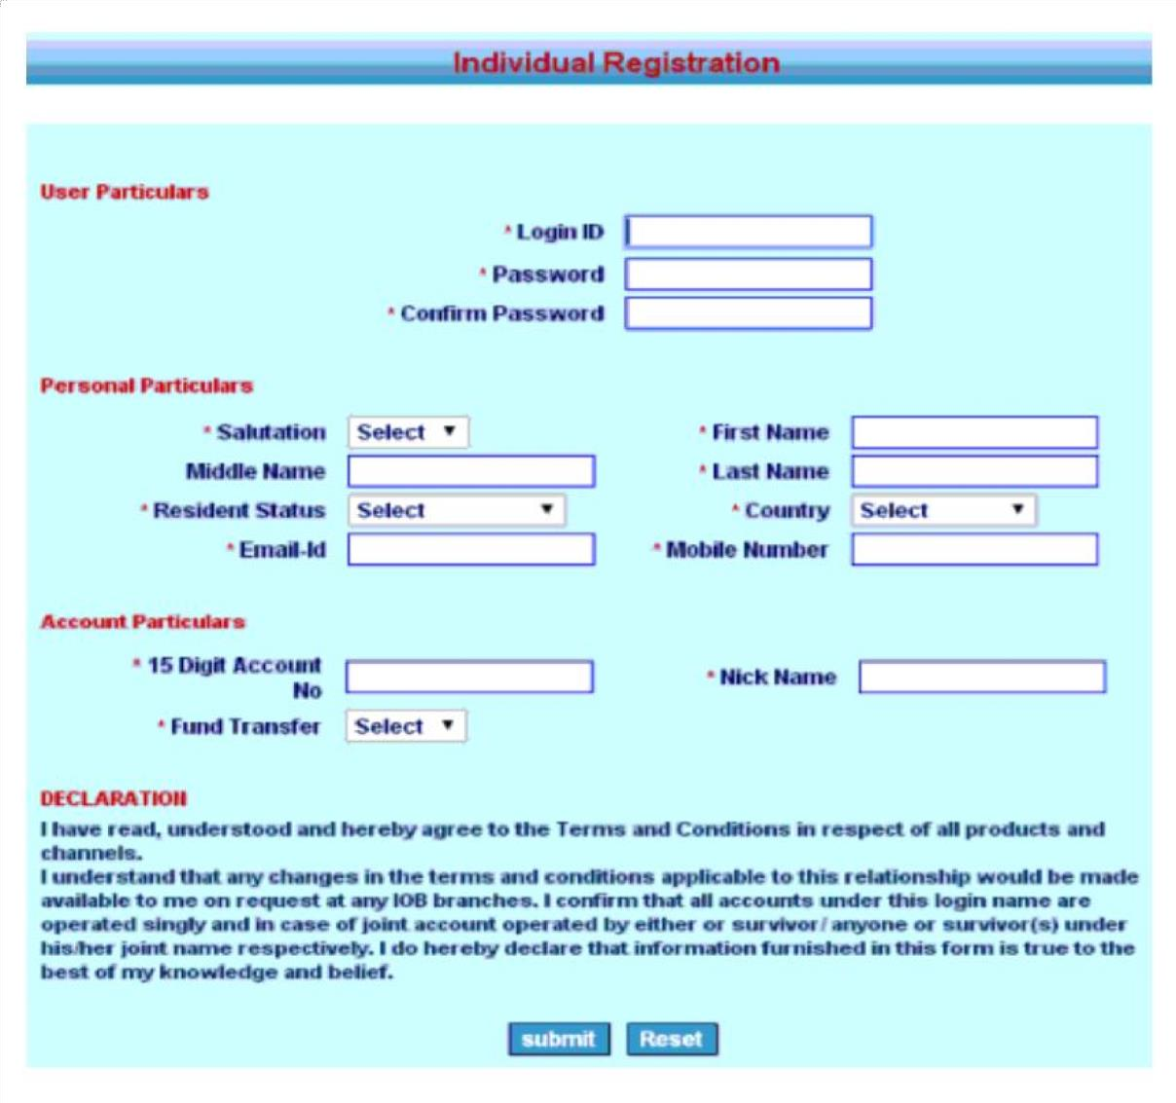

Code:

<!DOCTYPE html>

 <html lang="en">

 <head>

     <meta charset="UTF-8">

     <meta name="viewport" content="width=device-width, initial-scale=1.0">

     <title>Document</title>

     <style>

         *{

             margin: 0;

             padding: 0;

             box-sizing: border-box;

         }

         .top{

             height: 50px;

             width: 100%;

             background-color: rgb(8, 123, 168);

             color: red;

         }

         .two{

             height: 130px;

             width: 100%;

             background-color: rgb(15, 68, 148);

         }

         .three{

             height: 130px;

             width: 100%;

             background-color: rgb(15, 68, 148);

             display: flex;

         }

         .three1{

             height: inherit;

             width: 40%;

             background-color: rgb(15, 68, 148);

         }

         .three2{

             height: inherit;

             width: 60%;

             background-color: rgb(15, 68, 148);

         }

         .four{

             height: 100px;

             width: 100%;

             background-color: rgb(15, 68, 148);

             display: flex;

         }

         .four1{

             height: inherit;

             width: 40%;

             background-color: rgb(15, 68, 148);

         }

         .four2{

             height: inherit;

             width: 60%;

             background-color: rgb(15, 68, 148);

         }

         .dec{

             height: 180px;

             width: 100%;

             background-color: rgb(15, 68, 148);

         }

     </style>

 </head>

 <body>

     <div class="top">

         <h1 style="margin-left: 20%;">Individual Registration</h1>

     </div><br><br>

     <div class="two"><br>

         <p style="margin-left: 20px; color: rgb(148, 6, 6); font-weight: bolder;font-size: large;">User particulars</p>

         <div class="table1" style="text-align: right;">

             <table style="margin-left: 20%;">

                 <tr>

                     <td align="right" style="color: rgb(148, 6, 6); font-weight: 900;">*Login ID</td><td>&nbsp;&nbsp;&nbsp;<input type="text" style="border-radius: 5px;"></td>

                 </tr>

                 <tr>

                     <td align="right" style="color: rgb(148, 6, 6); font-weight: 900;">*Password</td><td>&nbsp;&nbsp;&nbsp;<input type="password" style="border-radius: 5px;"></td>

                 </tr>

                 <tr>

                     <td align="right" style="color: rgb(148, 6, 6); font-weight: 900;">*Confirm Password</td><td>&nbsp;&nbsp;&nbsp;<input type="password" style="border-radius: 5px;"></td>

                 </tr>

             </table>

         </div>

     </div>

     <div class="three">

         <div class="three1">

             <p style="margin-left: 20px; color: rgb(148, 6, 6); font-weight: bolder;font-size: large;">Personal particulars</p>

             <table style="margin-left: 30%;">

                 <tr>

                     <td align="right" style="color: rgb(148, 6, 6); font-weight: 900;">*Salutation</td>

                     <td>&nbsp;&nbsp;&nbsp;<select name="" id="">

                         <option value="" selected disabled>Select&nbsp;&nbsp;&nbsp;</option>

                         <option value="">Mr.</option>

                         <option value="">Ms.</option>

                         <option value="">Mrs.</option>

                     </select></td>

                 </tr>

                 <tr>

                     <td align="right" style="color: rgb(148, 6, 6); font-weight: 900;">*Middle Name</td><td>&nbsp;&nbsp;&nbsp;<input type="text" style="border-radius: 5px;"></td>

                 </tr>

                 <tr>

                     <td align="right" style="color: rgb(148, 6, 6); font-weight: 900;">*Resident Status</td>

                     <td>&nbsp;&nbsp;&nbsp;<select name="" id="">

                         <option value="" selected disabled>Select&nbsp;&nbsp;&nbsp;&nbsp;&nbsp;&nbsp;</option>

                         <option value="">one</option>

                         <option value="">two</option>

                         <option value="">three</option>

                     </select></td>

                 </tr>

                 <tr>

                     <td align="right" style="color: rgb(148, 6, 6); font-weight: 900;">*Email</td><td>&nbsp;&nbsp;&nbsp;<input type="email" style="border-radius: 5px;"></td>

                 </tr>

             </table>

         </div>

         <div class="three2"><br>

             <table>

                 <tr>

                     <td align="right" style="color: rgb(148, 6, 6); font-weight: 900;">*First Name</td><td>&nbsp;&nbsp;&nbsp;<input type="text" style="border-radius: 5px;"></td>

                 </tr>

                 <tr>

                     <td align="right" style="color: rgb(148, 6, 6); font-weight: 900;">*Last Name</td><td>&nbsp;&nbsp;&nbsp;<input type="text" style="border-radius: 5px;"></td>

                 </tr>

                 <tr>

                     <td align="right" style="color: rgb(148, 6, 6); font-weight: 900;">*Country</td>

                     <td>&nbsp;&nbsp;&nbsp;<select name="" id="">

                         <option value="" selected disabled>Select&nbsp;&nbsp;&nbsp;&nbsp;&nbsp;&nbsp;</option>

                         <option value="">India</option>

                         <option value="">Pakistan</option>

                         <option value="">Srilanka</option>

                         <option value="">bangladesh</option>

                         <option value="">nepal</option>

                         <option value="">japan</option>

                     </select></td>

                 </tr>

                 <tr>

                     <td align="right" style="color: rgb(148, 6, 6); font-weight: 900;">*Mobile number</td><td>&nbsp;&nbsp;&nbsp;<input type="text" minlength="1" maxlength="10" style="border-radius: 5px;"></td>

                 </tr>

             </table>

         </div>

     </div>

     <div class="four">

         <div class="four1">

             <p style="margin-left: 20px; color: rgb(148, 6, 6); font-weight: bolder;font-size: large;">Account particulars</p>

             <table style="margin-left: 30%;">

                 <tr>

                     <td align="right" style="color: rgb(148, 6, 6); font-weight: 900;">*15 Digit Account <br>number</td><td>&nbsp;&nbsp;&nbsp;<input type="text" minlength="1" maxlength="10" style="border-radius: 5px;"></td>

                 </tr>

                 <tr>

                     <td align="right" style="color: rgb(148, 6, 6); font-weight: 900;">*Fund Transfer</td>

                     <td>&nbsp;&nbsp;&nbsp;<select name="" id="">

                         <option value="" selected disabled>Select&nbsp;&nbsp;&nbsp;&nbsp;&nbsp;&nbsp;</option>

                         <option value="">one</option>

                         <option value="">two</option>

                         <option value="">three</option>

                     </select></td>

                 </tr>

             </table>

         </div>

         <div class="four2"><br>

             <table><br>

                 <tr>

                     <td align="right" style="color: rgb(148, 6, 6); font-weight: 900;">&nbsp;&nbsp;&nbsp;&nbsp;&nbsp;&nbsp;&nbsp;*Nick Name</td><td>&nbsp;&nbsp;&nbsp;<input type="text" style="border-radius: 5px;"></td>

                 </tr>

             </table>

         </div>

     </div>

     <div class="dec">

         <p style="margin-left: 20px; color: rgb(148, 6, 6); font-weight: bolder;font-size: large;">DECLARATION</p>

     <p style="margin-left: 20px; font-weight: 900;">

         I have read,understood and hereby agree to the Terms and Condition in respect of all products and channels.

     </p>

     <p style="margin-left: 20px; font-weight: 900;">

         I understand that any changes in the terms and condition applicable to this relationship would be made available to me on request <br>at any IOB branches. I confirm that all accounts under this login name are operated singly and in cavse of joint account operated by <br>either or survivor / anyone or survivors under his/her joint name respectively. I do hereby declare that information furnished in <br>this form is true to the best of my knowledge and belief.

     </p><br><br>

     <input type="submit" style="width: 100px;margin-left: 30%;">&nbsp;&nbsp;&nbsp;&nbsp;<input type="reset" style="width: 100px;">

     </div>

 </body>

 </html>

Output:

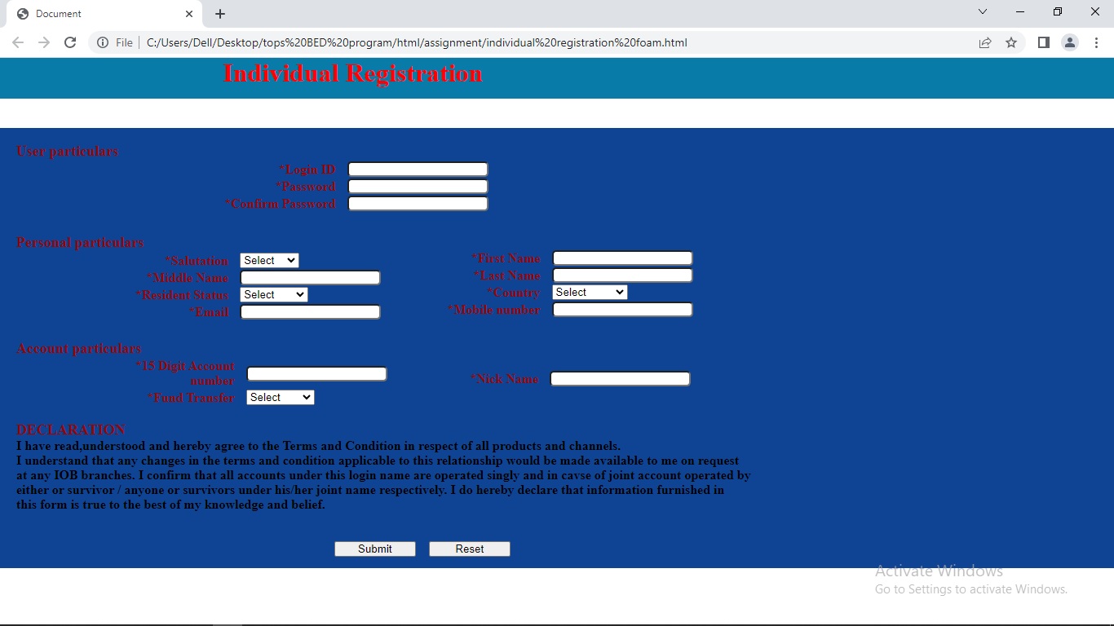

* Create link-pseudo classes using external css, to format links on the pages.

Code:

Html:

<!DOCTYPE html>

<html lang="en">

<head>

    <meta charset="UTF-8">

    <meta name="viewport" content="width=device-width, initial-scale=1.0">

    <title>Document</title>

    <link rel="stylesheet" href="C:\Users\Dell\Desktop\tops BED program\html\assignment\pseudoclass.css">

</head>

<body>

    <div>

        <a href="abc">pseudoclass using external CSS</a>

    </div>

</body>

</html>

CSS:

a:link {

    text-decoration:none;

  }

  a:hover {

    color: red;

    text-decoration: none;

  }

  a:active {

    color: green;

  }

Output:

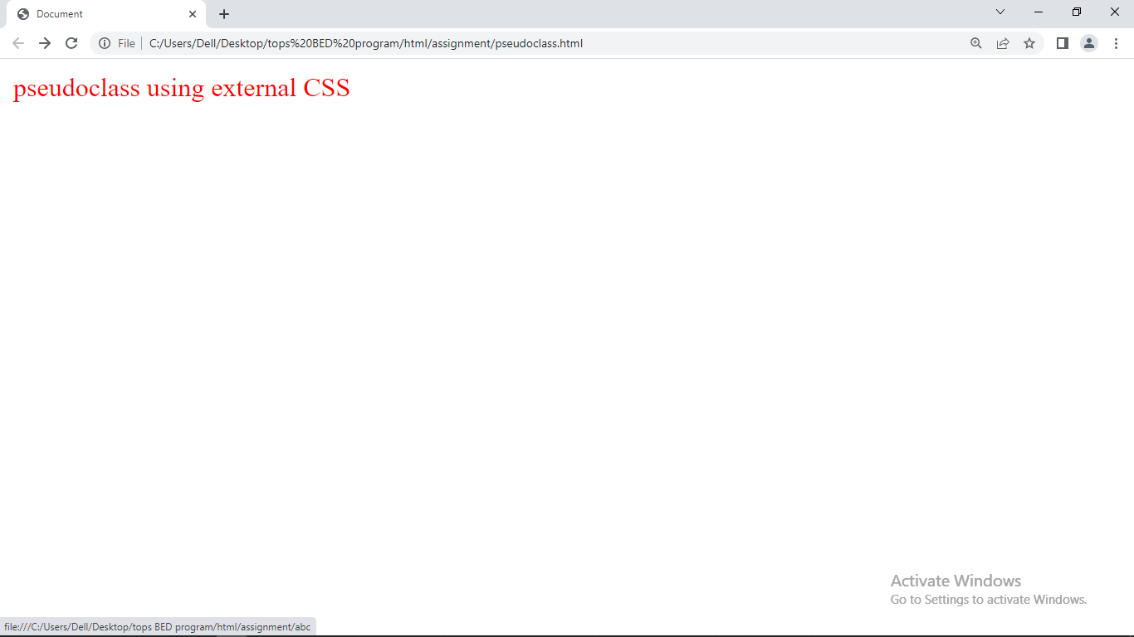

* Create a dynamic pseudo class using HTML, CSS

Code:

<!DOCTYPE html>

<html lang="en">

<head>

    <meta charset="UTF-8">

    <meta name="viewport" content="width=device-width, initial-scale=1.0">

    <title>Document</title>

    <style>

        input:focus {

          outline: 2px solid blue;

        }

      </style>

    </head>

    <body>

      <label for="name">Name:</label>

      <input type="text" id="name" placeholder="Enter your name">

    </body>

    </html>

Output:

